Lab Assignment 3-1 Bash Shell Linux+ and LPIC-1

- Create an alias called “MM” that displays only those filesystems that are mounted and are type ext4 filesystems.
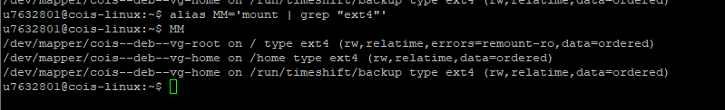
- Create and export a variable called NEWHOME that is equivalent to the value contained in the HOME variable.

- Find all files that start with the word “host” starting from the /etc directory and save the Standard Output to a file called fileout and Standard Error to a file called fileerr.
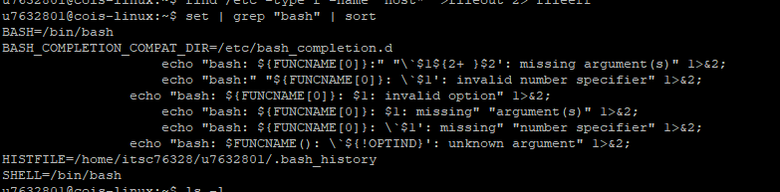
- Display only the lines from the output of the set command that the word “bash” in them. This output should be sorted alphabetically.
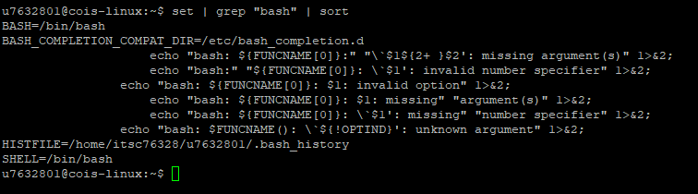
- Display only the user name (first field) in the colon-delimited /etc/password file and save the output to a file called users.
awk -F: '{print $1}' /etc/passwd > users
- Redirect the output of the ls –l ~ command to a file named mydirectory.
ls -l ~ > mydirectory
- Pipe the output of the ls –al / to the more utility
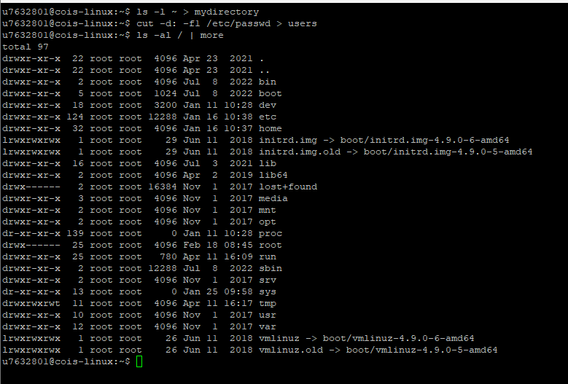
- Assume you have two files: text1 and text2, concatenate the output of text2 to text1.
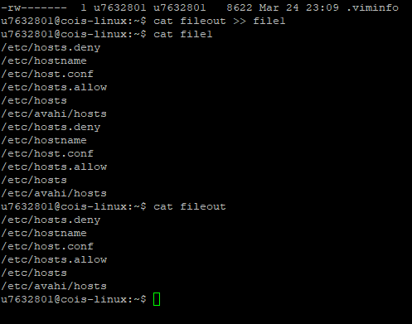
- Change the prompt on your computer to: “This is a new prompt: $”
export PS1="This is a new prompt: \$ "
source ~/.bashrc

- Display a list of the last 10 commands executed on your system.
